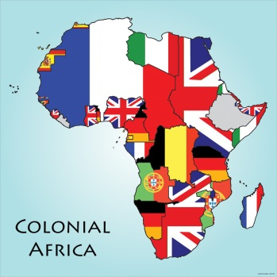
Poisonwood Bible Background Research
Task: As a group, research your assigned topic and determine the most effective way to present the information to your classmates. You will have 8 minutes to present all the essential information on ________. You will have 2 class periods to work on this. Use your time wisely and divide and conquer. If necessary, work together during lunch and after school to meet your group’s goals. *You MUST turn in an MLA “Works Cited” page to me at time of presentation! Do it the Da Vinci way: DISCOVER important information about your topic. What’s essential to share? CREATE something to share with us to show us what’s important about your topic. CONNECT your topic to our background knowledge. Why is this important? What does it have to do with PWB? REFLECT on your use of the pillars and creativity skills. Use at least 2 of the creativity skills.

TOPICS:

- Barbara Kingsolver. Show who she is, how she became interested in Poisonwood Bible, and outline her history as a student, writer, and family member.
- The Congo. Where is it in Africa? What are its geographical features? What are its sources of income? Describe/show the physical setting of this country; give a good idea of what the Price family faces.
- Communism. Define it. So what if it isn’t for everyone? How does it work? Where has it been attempted and successful? Attempted and failed? What is the U.S. perspective of it?
- Dwight D. Eisenhower. What was his relationship to the Congo? What was his role in Congolese history? Who was he? Describe his legacy and his working relationship with Patrice Lumumba and the CIA.
- Imperialism in Africa. The Congo, as well as many other countries in Africa, has been ruled by mostly European countries. Present an outline of who has taken over whom, when the African countries declared their independence, and how they are doing now.
- Patrice Lumumba. Who is he? Where did he lead? What ideals did he stand for? What happened to him? How was he important to the Congo?

Standards:
1.1.d. Develop a well-organized presentation to defend a position
1.1.f. Make strategic use of digital media (textual, graphical, audio, visual) in presentations to enhance understanding of findings, reasoning, and evidence and to add interest.
1.2.a.i. Work with peers to set rules for collegial discussions and decision-making (consensus, taking votes, presentation of alternate views), clear goals and deadlines, and individual roles as needed
1.2. g. Integrate multiple sources of information presented in diverse media or formats (visually, orally) evaluating the credibility and accuracy of each source
2.2.c. Evaluate clarity and accuracy of information through close text study and investigation via other sources
2.2.e. Use flexible reading and note-taking strategies to organize information and make connections within and across informational texts.
4.1. c. Judge the usefulness of information based on relevance to purpose, source, objectivity, copyright date, cultural and world perspective and support the decision

