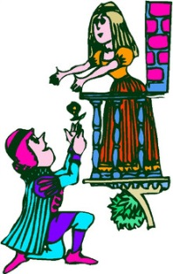
Reflect on 2.4-2.6
What is the mood of 2.4? Why are they joking so much?
What do they say about the Nurse? Why?
What is Juliet’s mood at the beginning of 2.5? What does the Nurse share with Juliet?
What advice does the Friar reiterate in 2.6?
Do Romeo and Juliet get married in this scene?

In groups identify examples of each different literary device. For each device write how they affect the meaning of what’s going on (basically explain the connotation behind the device, just like with poetry essay!) and character.
Pages:
- 777-778
- 779-780
- 781--end of scene 4
- 782--beginning scene 5-784
- 785-786
What do the quoted literary devices tell you about a character? (e.g. motives, personality, relationships, or potential conflicts)
SHARE!
Monday will be graded writing on this prompt so be ready!

