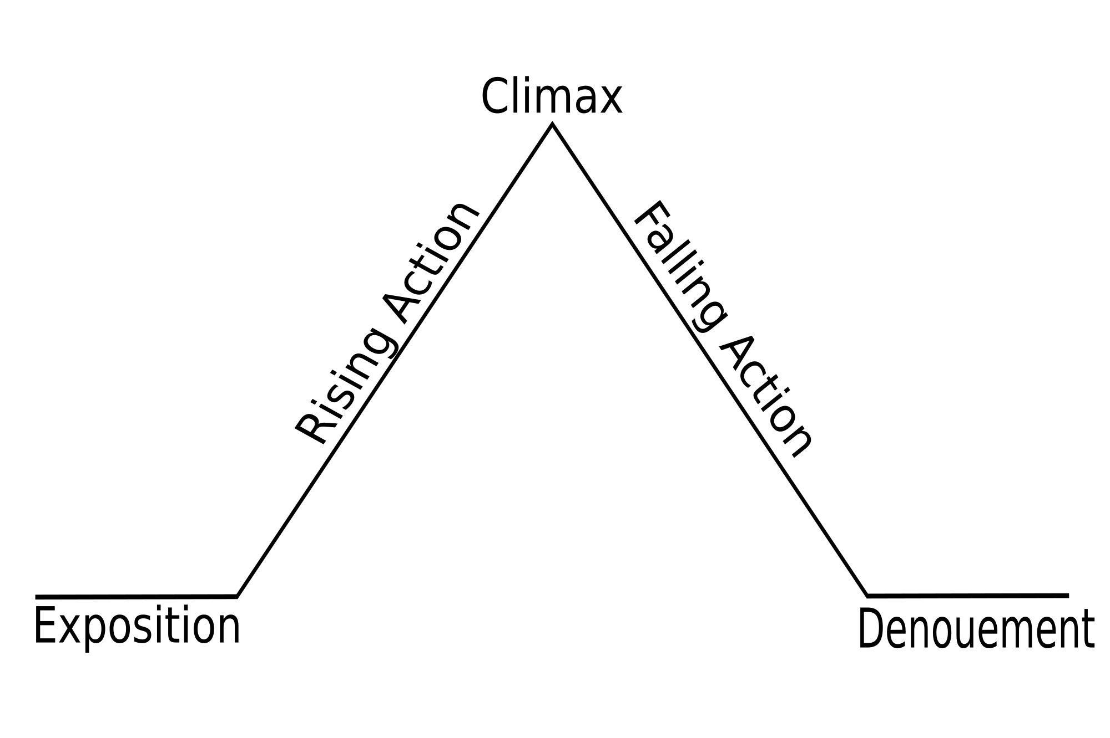Independent Reading Analysis #1: Short Stories

Honors English

Task Overview:
Freshman Honors English focuses on literary analysis writing, and our first formal essay will analyze a short story. To get you ready for this essay and to give you ample feedback on your writing, you will read ONE SHORT STORY PER WEEK, in addition to the stories read for class. After you independently read this story, you will write a literary analysis paragraph using the recipe format. Please read short stories from the textbook that you’ve NOT read before or ones that we will study as a class.

Requirements:
- Choose and read four (4) short stories from the textbook’s short story collections that interest you. Short Story Collections 1-4 (pp. 4-323 in the textbook) use the following themes:
  - Facing Monsters
  - The Human Spirit
  - Expect the Unexpected
  - Discoveries
- Do NOT read the following stories: “Harrison Bergeron,” “The Grave,” “Fleur,” and “The Conversion of the Jews.” Also, make sure that your readings are short stories, not the poems, essays, etc. contained in the collection. Check the table of contents to be sure.
- For each story you read, you will write a literary analysis paragraph on the assigned element. The reading of the story and the subsequent paragraph are due on the schedule listed below.
- Word process your paragraphs using the recipe format (on back). Topic Sentence (TS) should state short story title, author, and synthesis of your literary element’s importance to the story.
- Edit and revise each typed paragraph for publication quality.
- Please do NOT use any outside resources on this project.

Literary Element Topics Required by Week: Reading and Paragraph Due:

1. Conflict/resolution analysis ___________________________
(What is the conflict? What type of conflict is it? What is the resolution? How does the resolution solve the conflict? Why does the resolution have to happen in order to solve the conflict? How do the conflict & resolution help communicate the theme?)

2. Character analysis ____________________________
(Who is the protagonist? Is s/he round or flat? Static or dynamic? Who is the antagonist? How does the character and his/her change or lack of change help create the resolution or theme?)

3. Setting analysis ____________________________
(What is the setting? Think time, place, and mood. What is the conflict? How is the conflict a result of the setting? Could the setting be a character? How does the setting help communicate the theme?)

4. Point of View or cultural experience analysis _____________________________
(From what POV is the story told? What is the conflict? How does the POV impact the understanding of the conflict? What does the reader gain from the current POV? OR What is known of the cultural experience? How are the conflict and the cultural experience connected? In what ways does the cultural experience impact the resolution and theme?)

E.O. 2.1.a: Determine a theme or central idea of a text and analyze in detail its development over the course of the text, including how it emerges and is shaped and refined by specific details
E.O.2.1.b: Analyze how complex characters develop oer the course of a text, interact with other characters and advance the plot or develop the theme.
E.O.2.1.d: Analyze a particular point of view or cultural experience in literature
E.O.2.1.e.ii: Use literary terms to describe and analyze selections
Recipe for the Perfect Paragraph
(all your paragraphs should be 11 sentences and follow this format!)

- TS (topic sentence—a general, opinionated sentence which focuses the paragraph; addresses the prompt, story title, author, and analysis of literary element’s importance)

- CD (concrete detail—a specific fact or detail that we can usually see or hear and sometimes smell, taste or touch. This is evidence that supports your TS. THINK fact, quote, specific detail, paraphrase, or partial quote.)

- CM (commentary—opinions, thoughts, ideas, comments relating to your CDs. THINK insight, reflection, connections, or explanation of importance.)

- CM:

- CD:
- CM:
- CM:

- CD:
- CM:
- CM:

- CS (concluding sentence—the final sentence of your paragraph; sums up ideas, offers more commentary perhaps, gives the paragraph a finished feeling. THINK why is this element important to the story?)
TRASH CAN WORDS:

Clichés I, We, Us All forms of “to be” – are, was, were, be, being, been
There A lot NSSWTSW
That Great Avoid passive voice
You Really

**The introduction info for the short stories are typically on the left side of the textbook prior to the start of the short story. Please take the time to read this info since it will provide good information about which paragraph would work well for that particular story**

